13 RED VALENTINES DINNER OUTFIT WOMEN CLASSY INSPIRATIONS

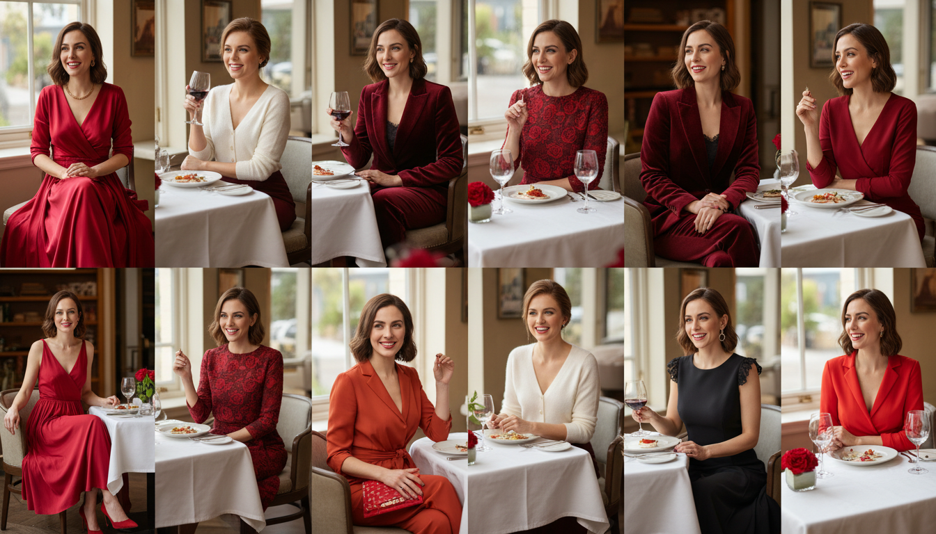

Getting ready for a big date is the most exciting part of the entire evening. You want a look that feels special but still stays totally sophisticated for a nice restaurant. Red is the most powerful color you can wear to show off your confidence and romantic side. These 13 Red Valentines Dinner Outfit Women Classy Inspirations are exactly what you need to feel like your best self. I have gathered the most stylish looks that focus on rich fabrics and amazing fits. From soft silks to cozy knits, these pieces are guaranteed to make a statement. You are going to look absolutely incredible tonight. Save these ideas to your fashion board now.

# Silk Slip Red Valentine's Dinner Outfit

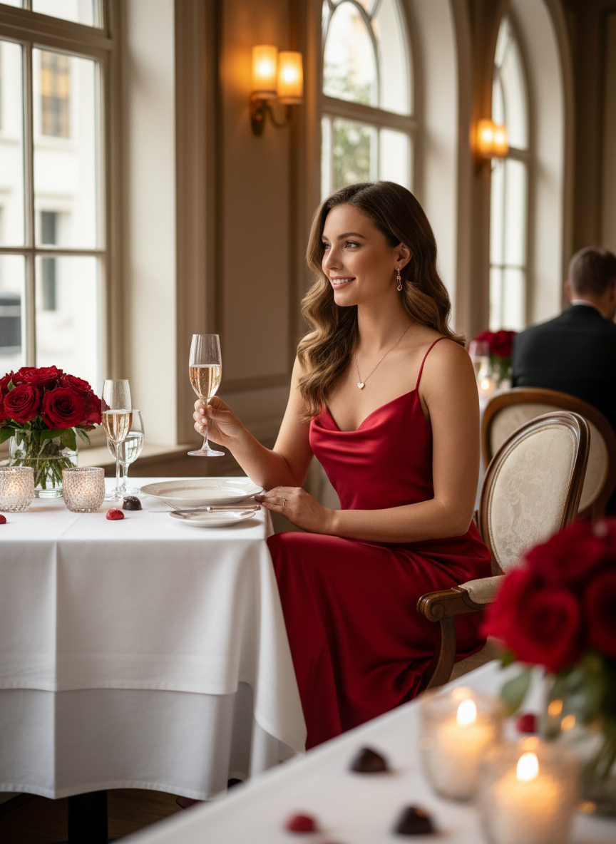

A simple silk slip dress is a total classic for a reason. The fabric hangs perfectly and catches the light during a candlelit dinner. Pair it with some dainty gold jewelry to keep things elegant. It looks amazing with a pair of strappy heels and a small clutch. This red Valentine's dinner outfit is basically the definition of effortless beauty.

# Velvet Mini Red Valentine's Dinner Outfit

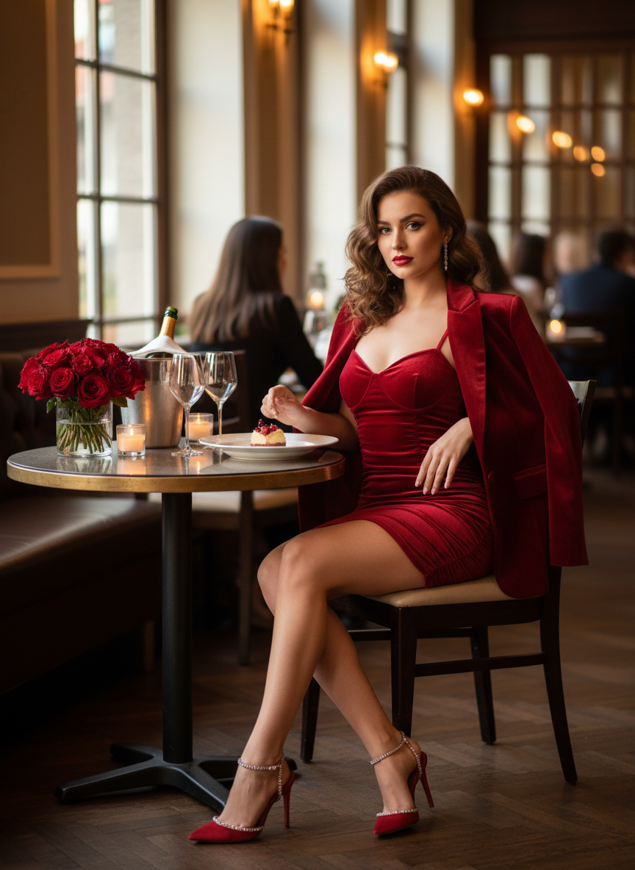

Velvet is a very rich material that feels so cozy for a chilly February night. Choose a deep red shade to keep the look expensive and mature. Long sleeves add a nice touch that keeps the outfit balanced. This choice is perfect if you want to feel soft and glamorous at the same time.

# Off-the-Shoulder Red Valentine's Dinner Outfit

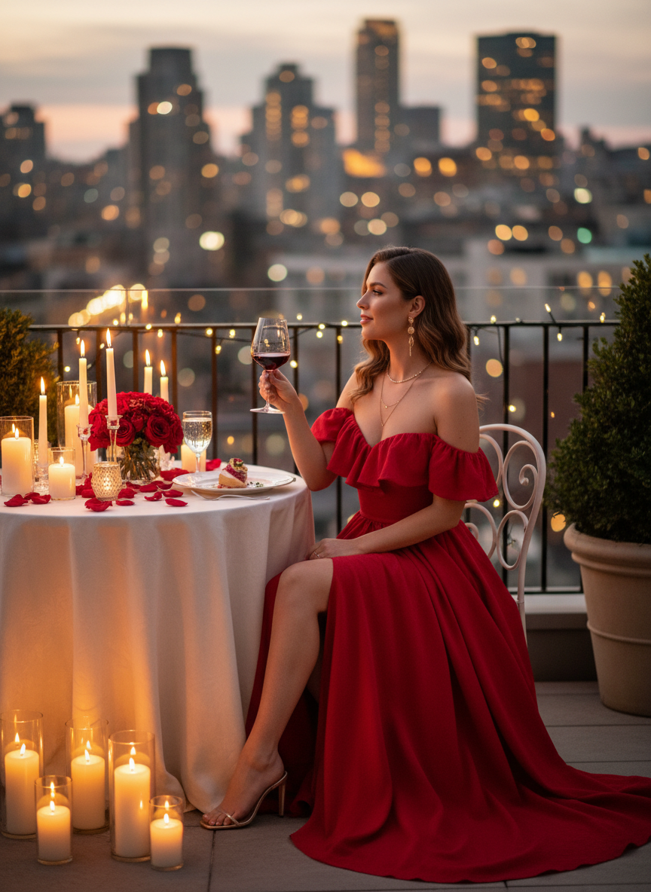

Showing a little skin at the shoulders is a great way to be flirty while staying classy. A fitted midi dress in a bright crimson color works wonders for your silhouette. It highlights your frame without being too much for a fancy setting. Stick to neutral heels to let the dress do all the talking.

# Satin Blouse Red Valentine's Dinner Outfit

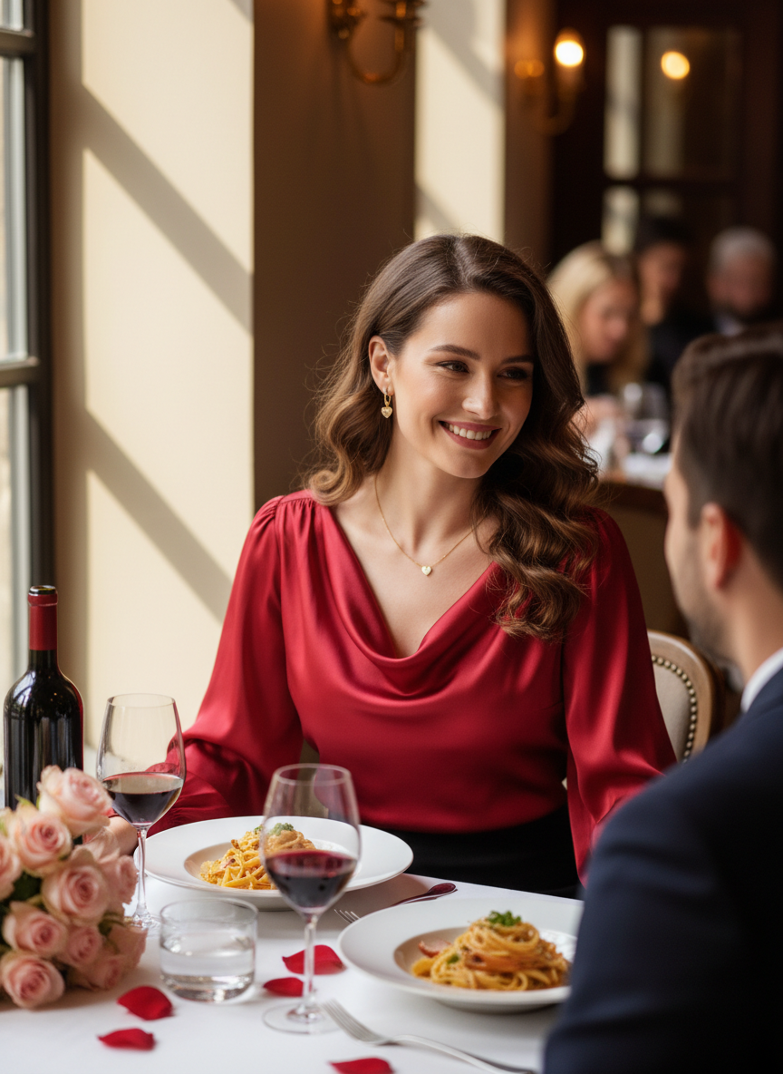

If you prefer wearing pants, a satin blouse is a fantastic choice for your date. Tuck a bright red top into some high-waisted black trousers for a sharp and modern look. The contrast between the red fabric and the dark pants is very chic and professional. This red Valentine's dinner outfit works perfectly for a city dinner or a nice gallery event. Add a pair of pointed-toe pumps to finish the look.

# Lace Detail Red Valentine's Dinner Outfit

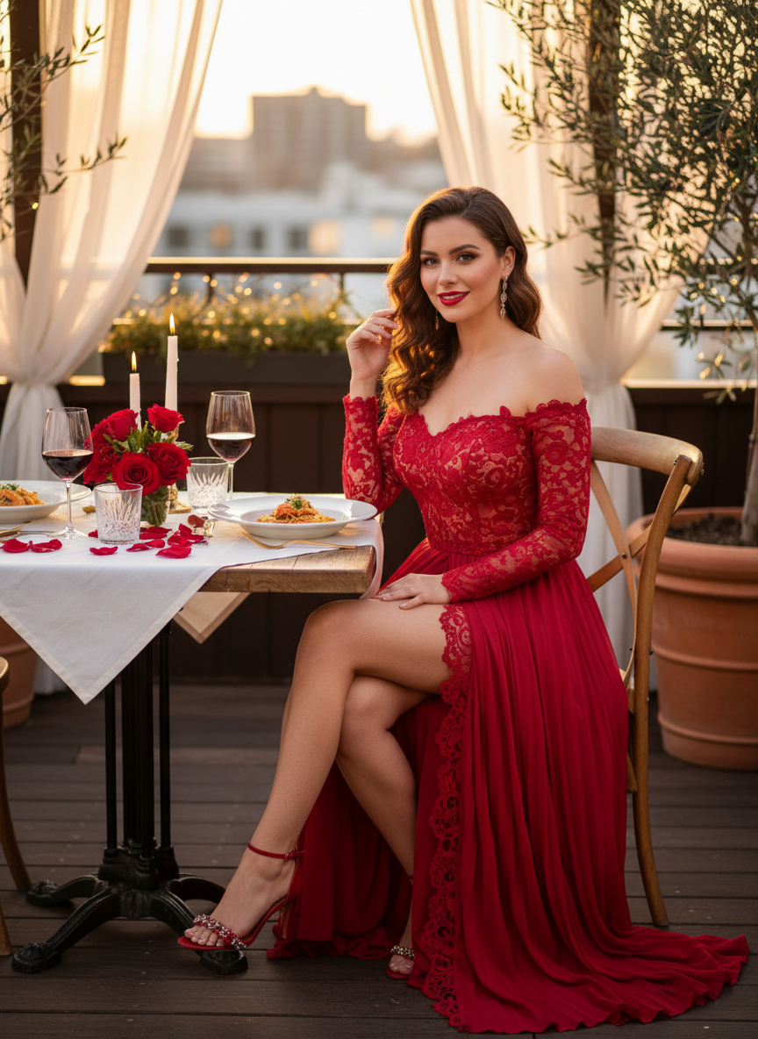

Lace adds a romantic texture that fits the mood of the night perfectly. A red dress with lace trim at the hem or neckline feels very feminine and delicate. Keep your hair in a sleek bun to let the intricate details of the dress shine. It is a timeless choice that never goes out of style.

# Bodycon Midi Red Valentine's Dinner Outfit

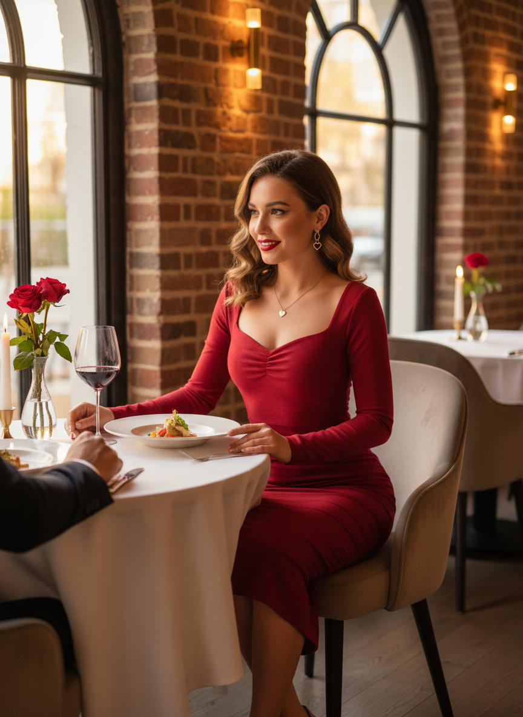

A classy bodycon midi dress is all about showing off your silhouette in a sophisticated way. Look for one with a high neckline or a modest length to balance out the tight fit. This red Valentine's dinner outfit looks great with some classic nude pumps. It is a simple look that makes a massive impact.

# Blazer Dress Red Valentine's Dinner Outfit

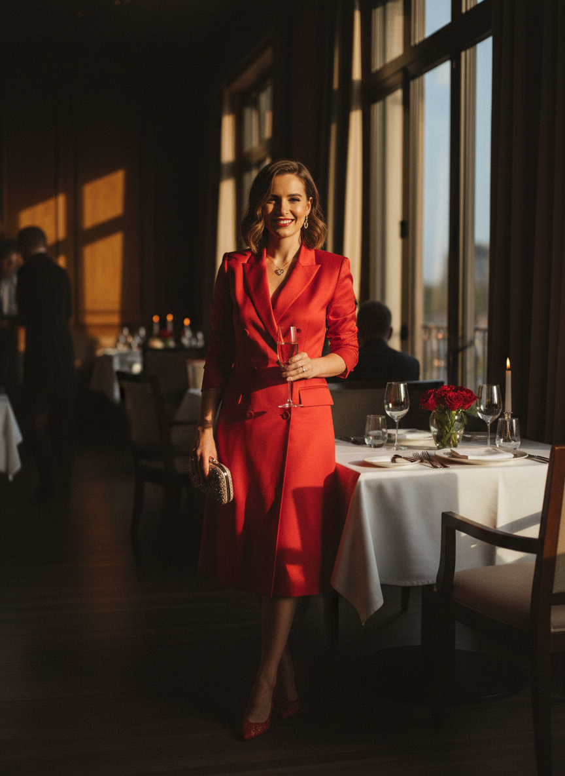

A blazer dress is a great power move for a dinner date. It looks structured and very put together while still being trendy enough for social media. Wear it with sheer black tights and pointed-toe boots for a modern edge. The bold red color makes the masculine cut feel much more feminine.

# Cut-Out Red Valentine's Dinner Outfit

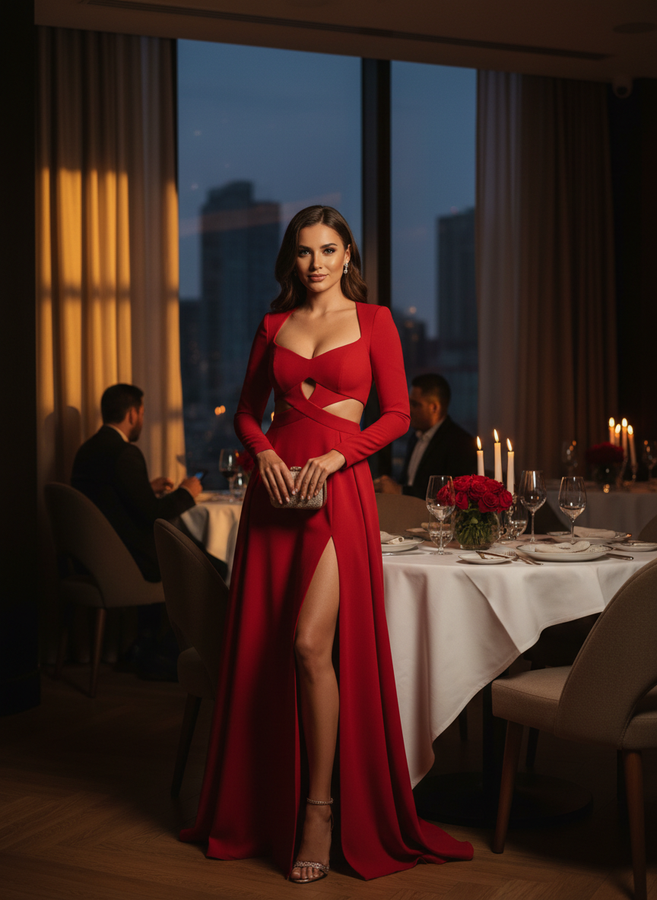

Small cut-outs at the waist or back add a trendy twist to a traditional red dress style. It makes the whole look feel fresh and youthful for a night out. Just make sure the cut-outs are subtle so you maintain that classy vibe. This red Valentine's dinner outfit is for the girl who wants to stand out from the crowd.

# Pleated Skirt Red Valentine's Dinner Outfit

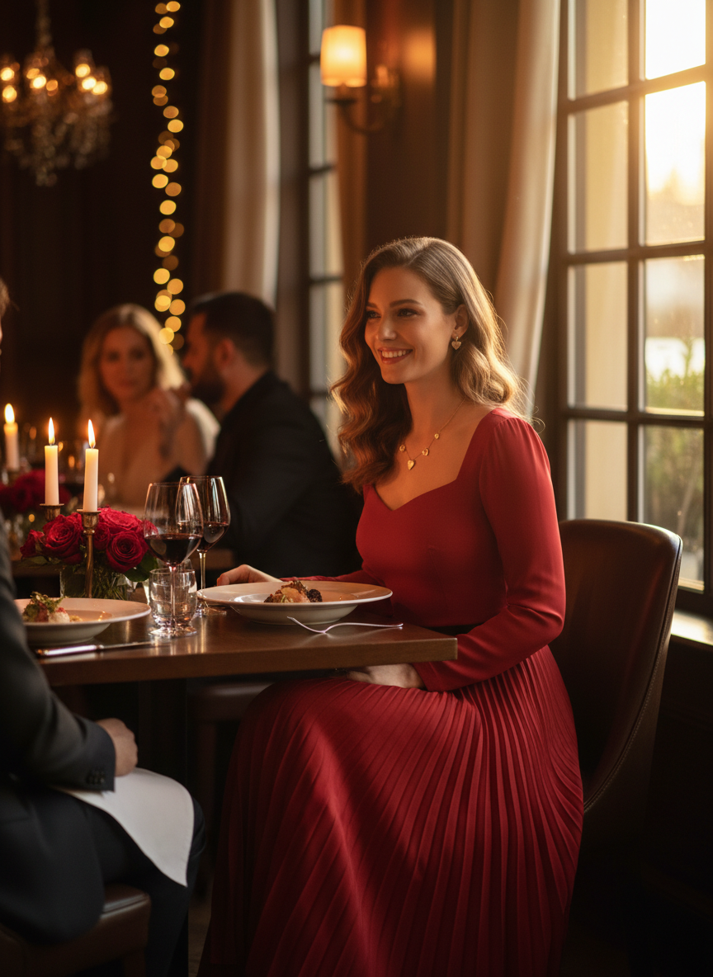

A flowy pleated skirt in a vibrant red is so much fun to wear because of how it moves. Match it with a white or cream knit sweater for a look that is both cozy and polished. This is a great way to stay comfortable while still looking like you put in effort.

# One-Shoulder Red Valentine's Dinner Outfit

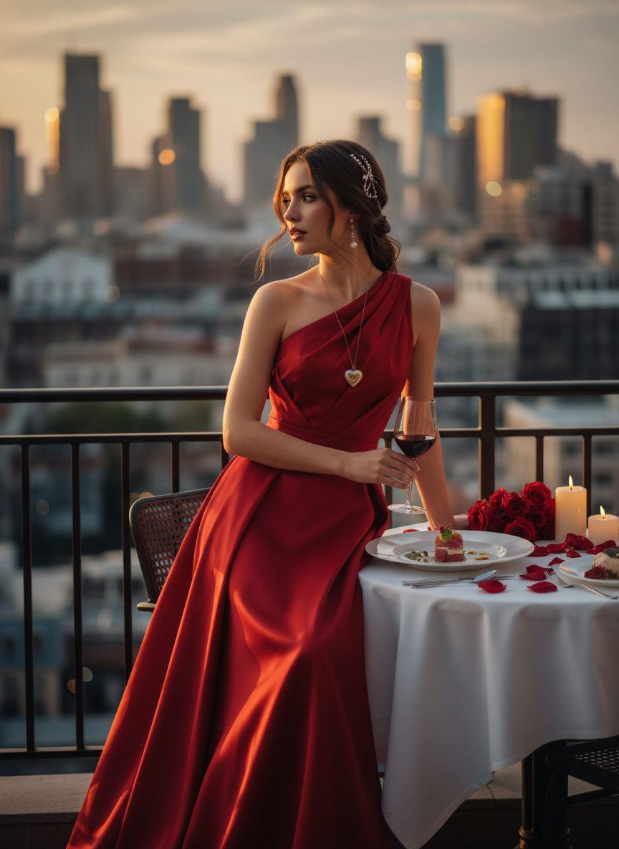

The one-shoulder look is very popular right now and always looks like a high-fashion choice. This style works best in a midi or maxi length to keep the proportions right. It creates a beautiful line that makes you look taller and more elegant for your dinner plans.

# Tulle Skirt Red Valentine's Dinner Outfit

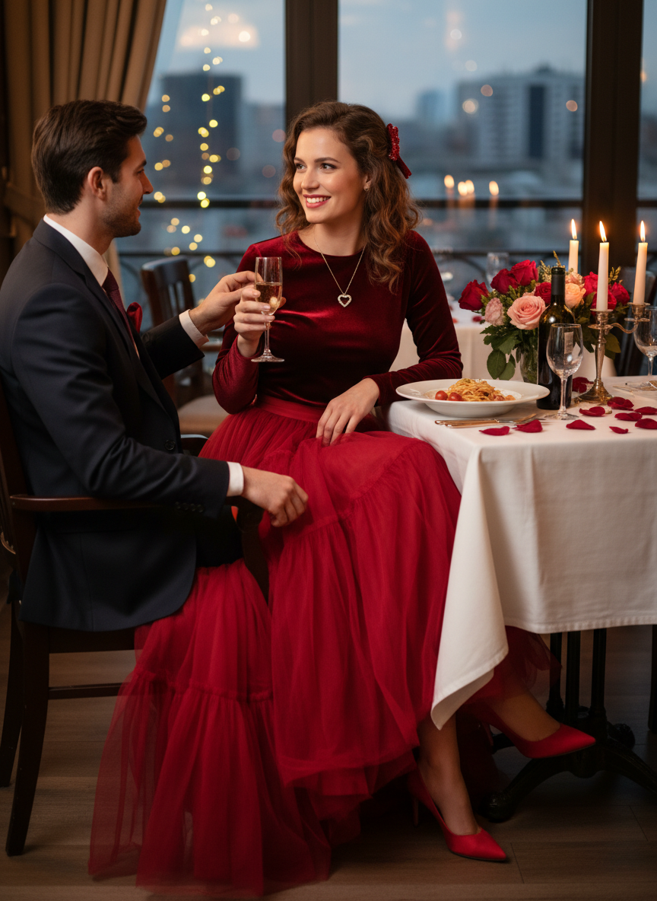

You can go for a fun and whimsical vibe with a big red tulle skirt. Pair it with a very simple black bodysuit so the skirt stays as the main star of the show. This red Valentine's dinner outfit is perfect for someone who loves a little bit of drama and fashion.

# Knit Midi Red Valentine's Dinner Outfit

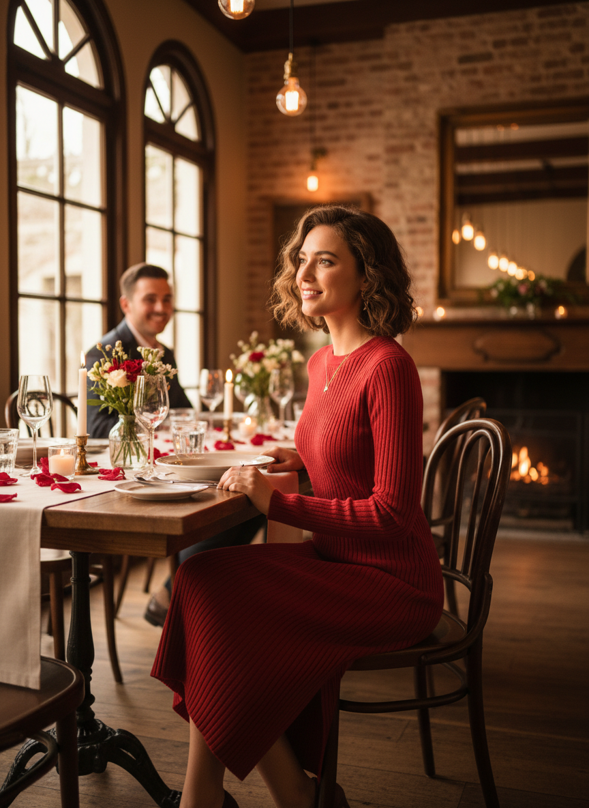

Knit dresses are so comfortable for sitting through a long multi-course dinner. A ribbed red knit dress hugs your body in all the right places while feeling like a blanket. Add a gold chain belt to cinch your waist and give the outfit more structure. It is the perfect mix of casual and fancy.

# Wrap Style Red Valentine's Dinner Outfit

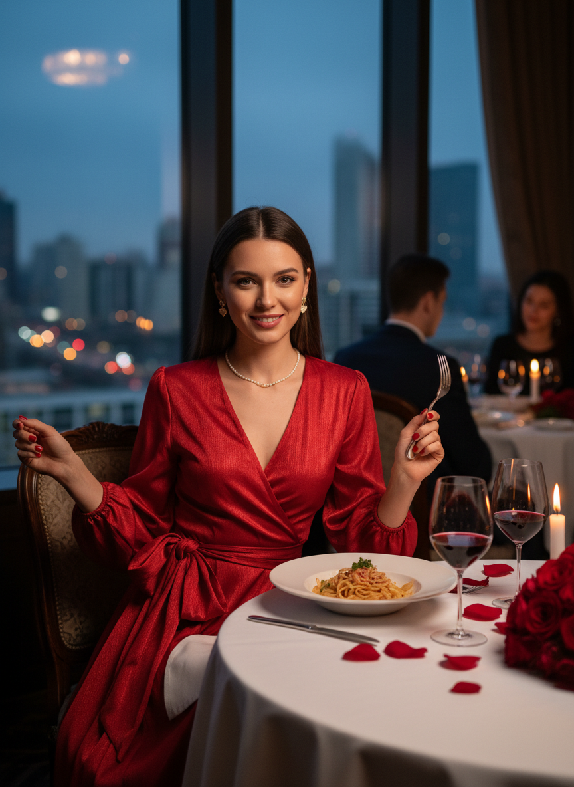

A wrap dress is famously flattering on every single body type. The V-neckline is a great spot to show off a sparkly statement necklace or a simple gold chain. This red Valentine's dinner outfit is a very reliable choice that works for almost any restaurant you might visit.

# Conclusion

Choosing a bold red look is the easiest way to feel confident and romantic for your big night. These ideas prove that you can wear bright colors and still look totally sophisticated for a fancy date. Whether you love the feel of silk or the comfort of a knit dress, there is a perfect style for your plans. Pick the one that makes you feel the most beautiful and walk into that restaurant with your head held high. Save these red dinner looks to Pinterest right now.